**Cosy Airconditioners**

***Developer* *Guide***

|  |  |  |
| --- | --- | --- |
| Supervisor | Tooba Khawar | |
| Batch. | 2109C2 | |
| Group. | B | |
| Serial No. | Enrollment Number | Student Name |
| 1. | Student1338821 | SOHAIL . |
| 2. | Student1336549 | MUHAMMAD SHAHARYAR . |
| 3. | Student1336558 | MUHAMMAD IRTEQA KHAN |
| 4. | Student1336555 | SYED YOUNUS ALI |

|  |
| --- |
| ***Developer Guide*** |

1.Home Page(Code View)

Figure:1

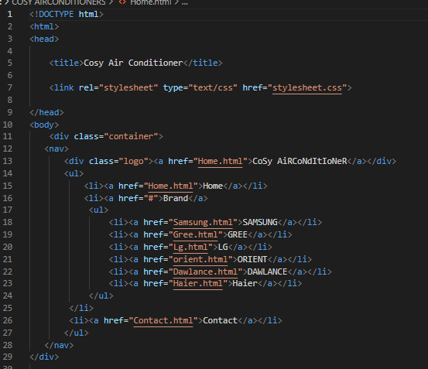

Figure:2

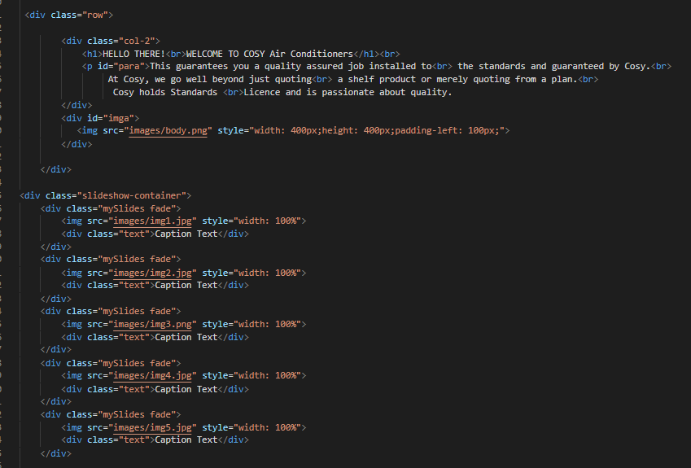

Figure:3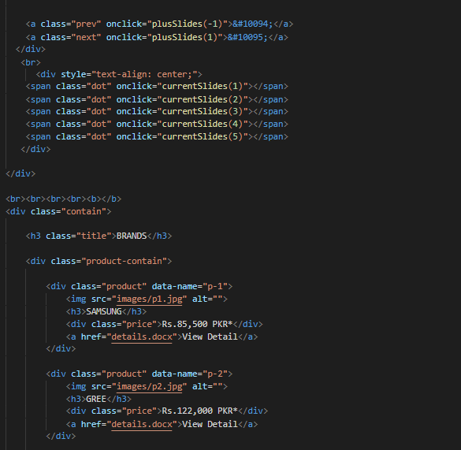

Figure:4

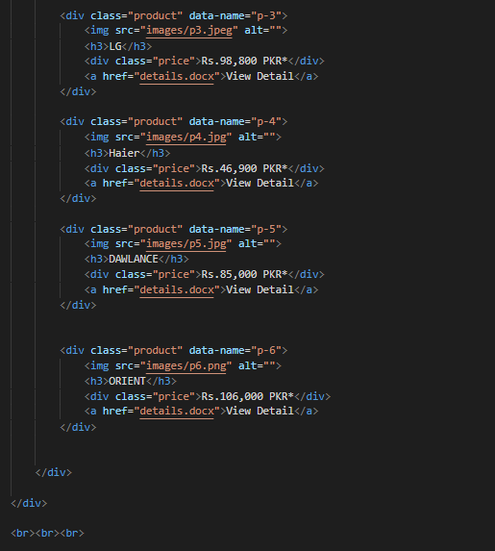

Figure:5

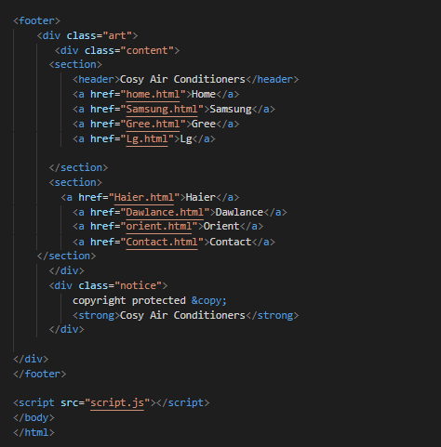

2.Samsung Page(Code View)

Figure: 6



Figure: 7

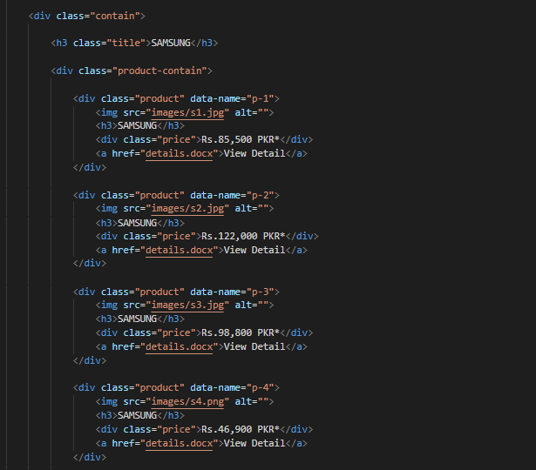

Figure: 8

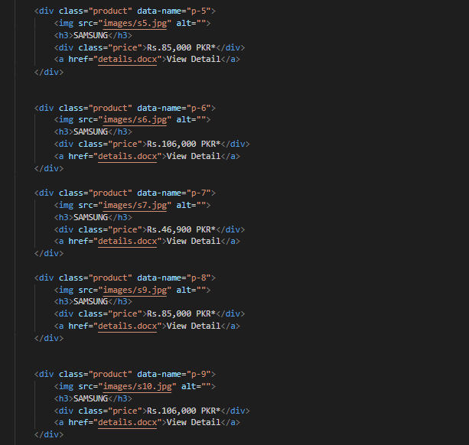

Figure: 9



3.Gree Page(Code View)

Figure: 10



Figure: 11

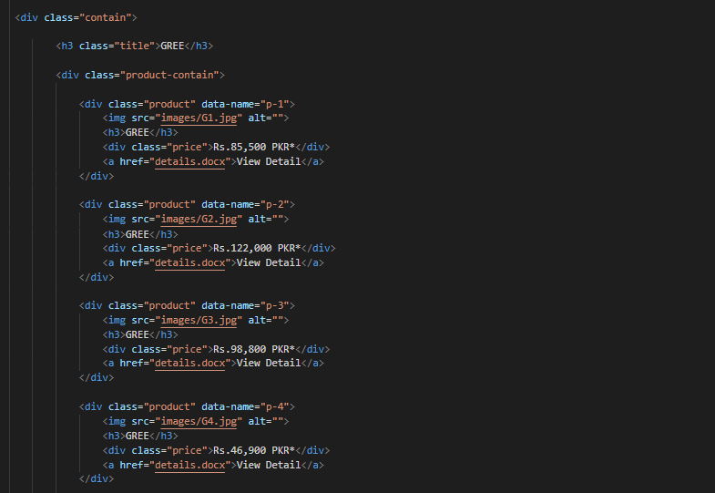

Figure: 12

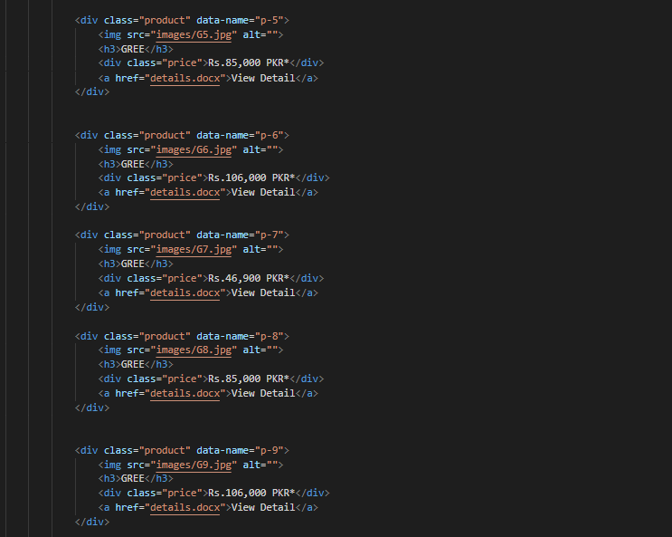

Figure: 13



4.Lg Page(Code View)

Figure: 14



Figure: 15

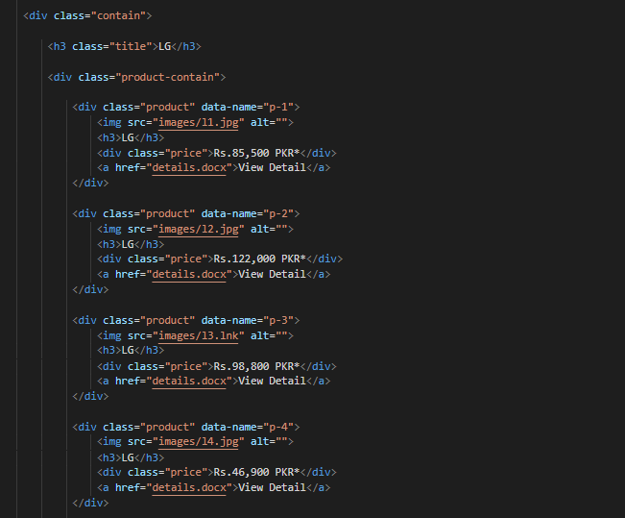

Figure: 16

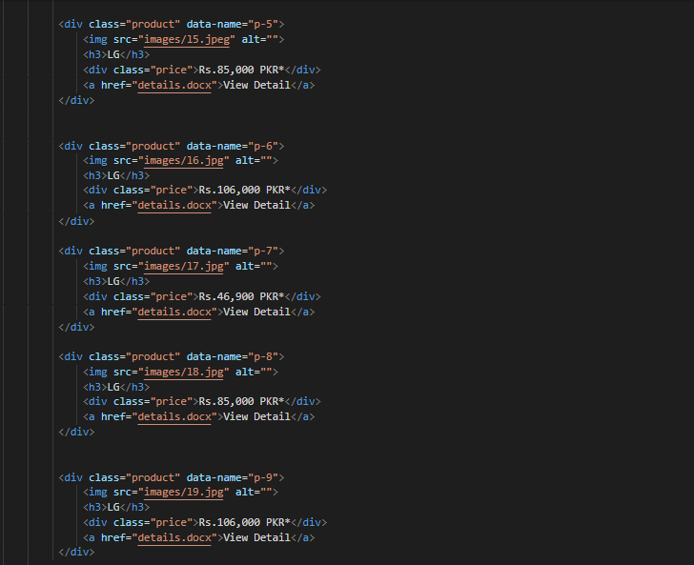

Figure:17



5.Haier Page(Code View)

Figure: 18



Figure: 19

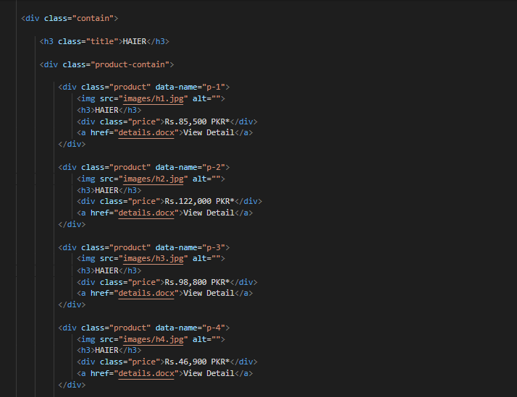

Figure: 20

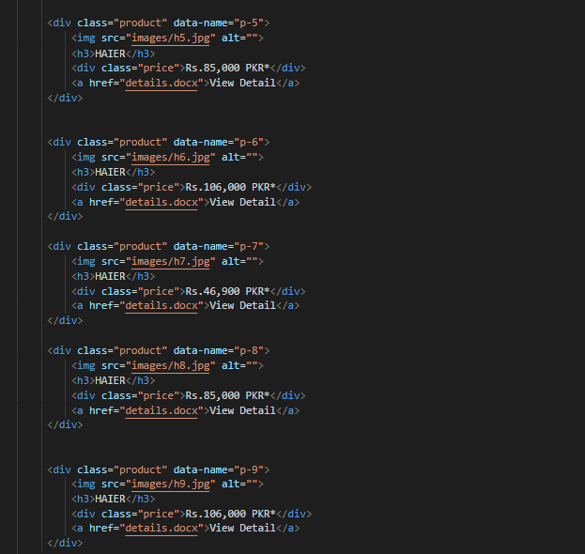

Figure: 21

6.Dawlance Page(Code View)

Figure: 22



Figure: 23

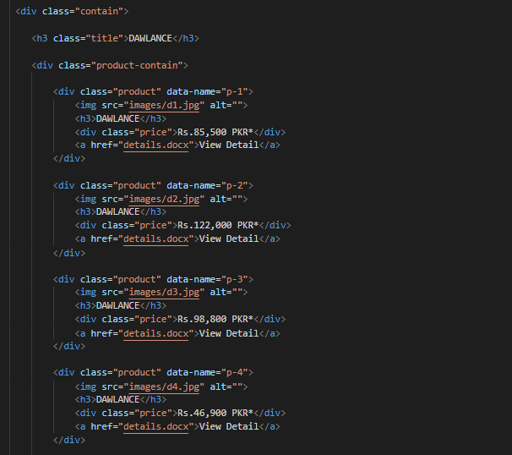

Figure: 24

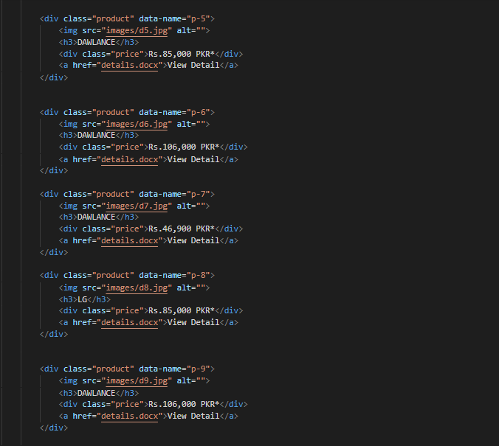

Figure: 25



7.Orient Page(Code View)

Figure: 26



Figure: 27

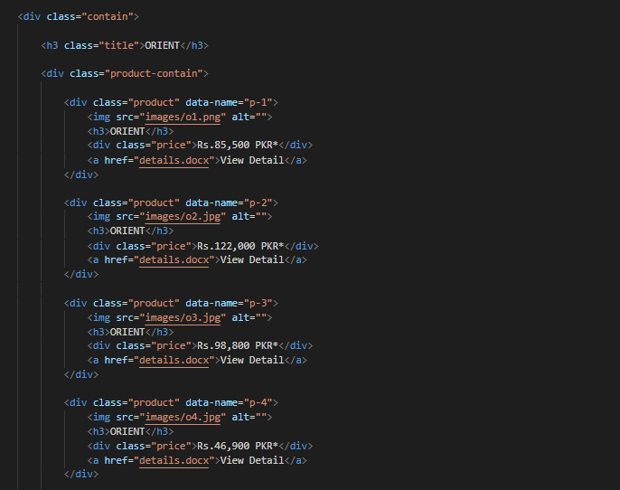

Figure:28

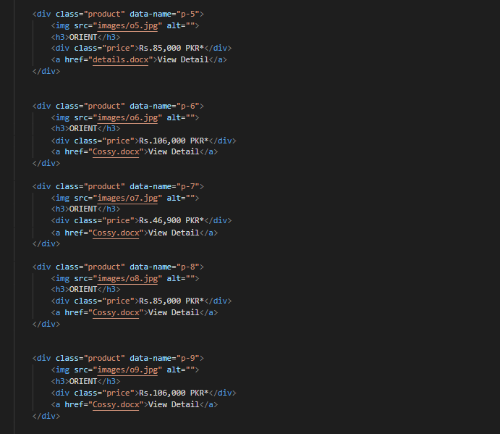

Figure: 29



8.Contact Page(Code View)

Figure: 30

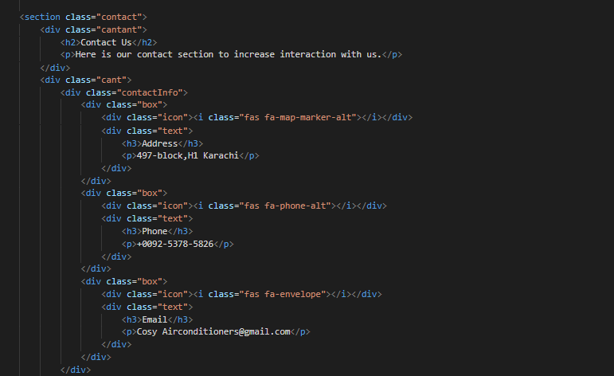

Figure: 31

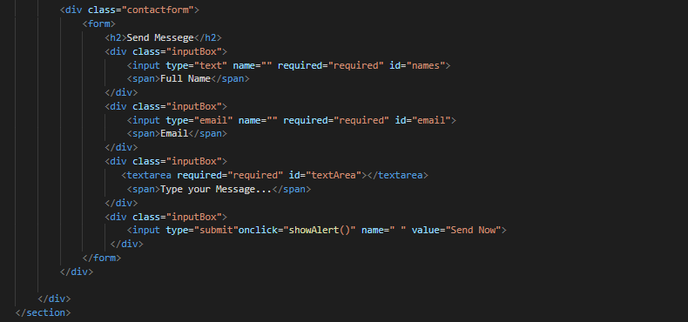

9.Style Sheet(Code View)

Figure: 32

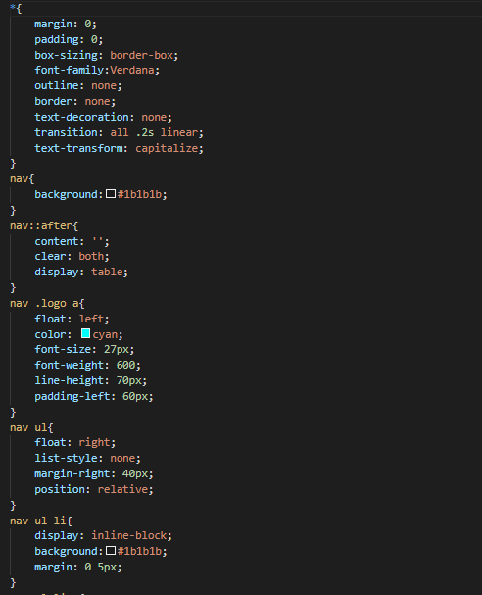

Figure: 33

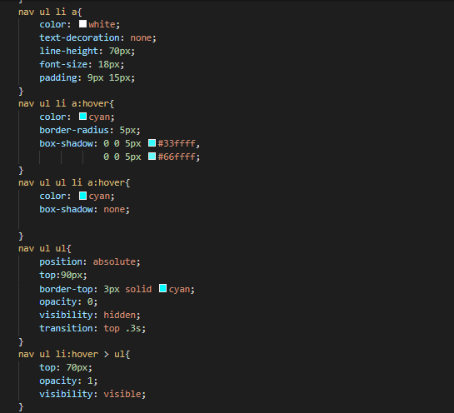

Figure: 34

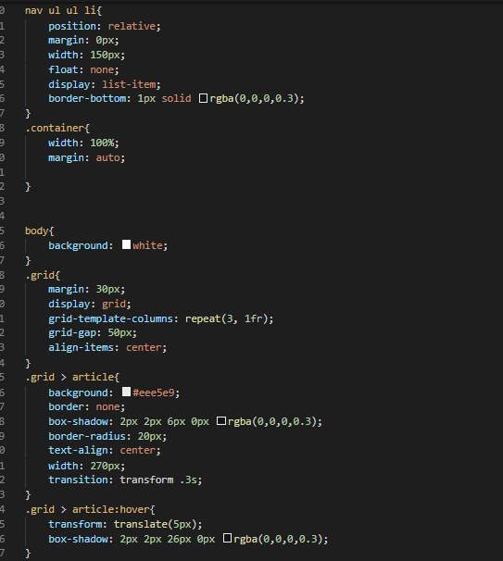

Figure: 35

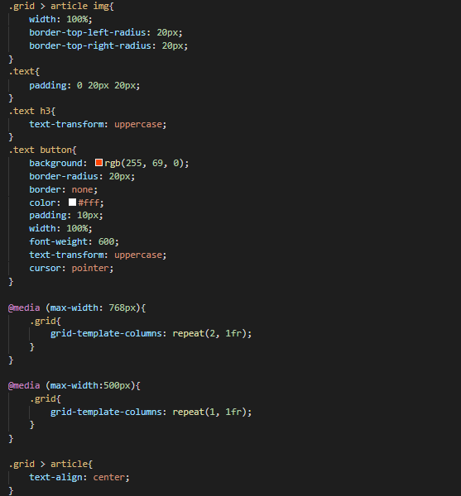

Figure: 36

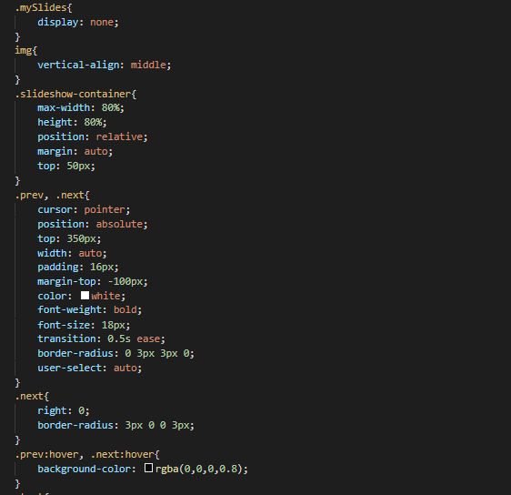

Figure: 37

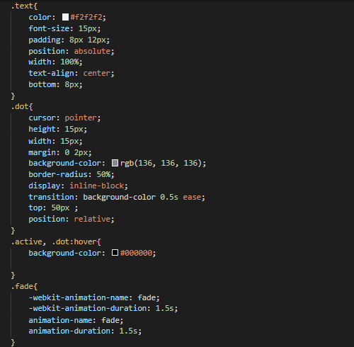

Figure: 38

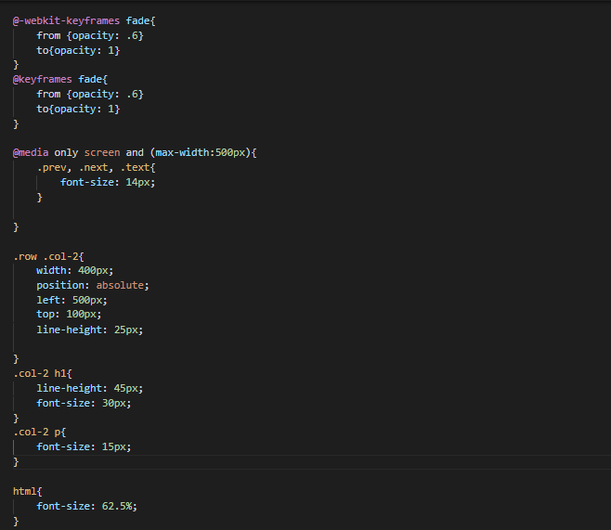

Figure: 39

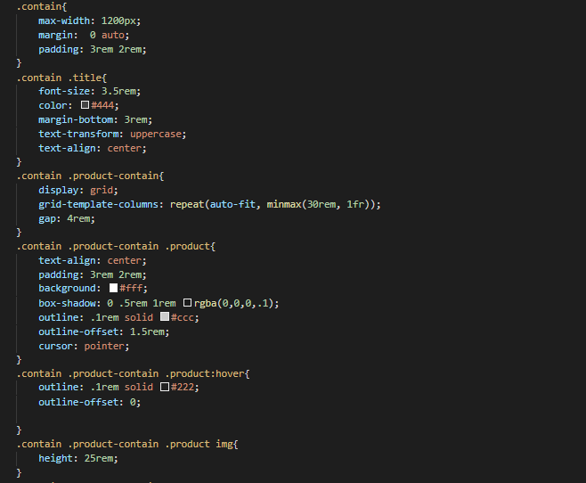

Figure: 40

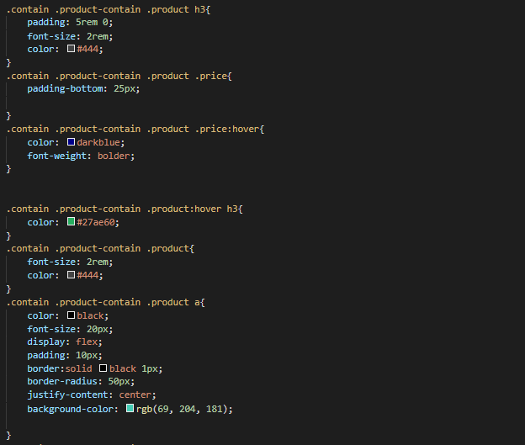

Figure: 41

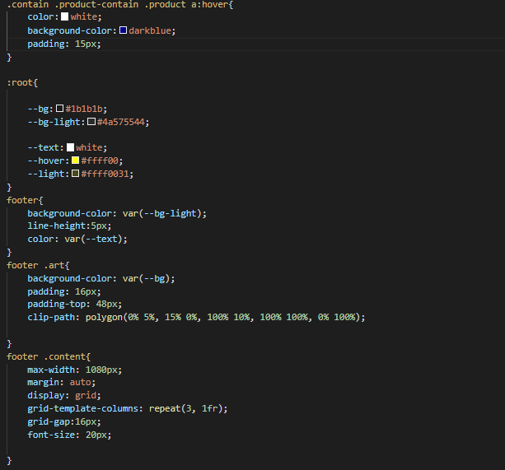

Figure: 42

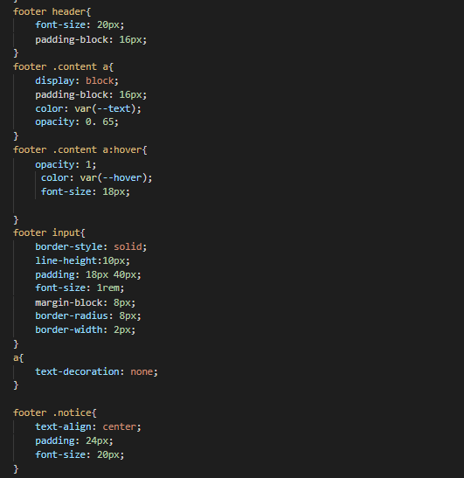

Figure: 43

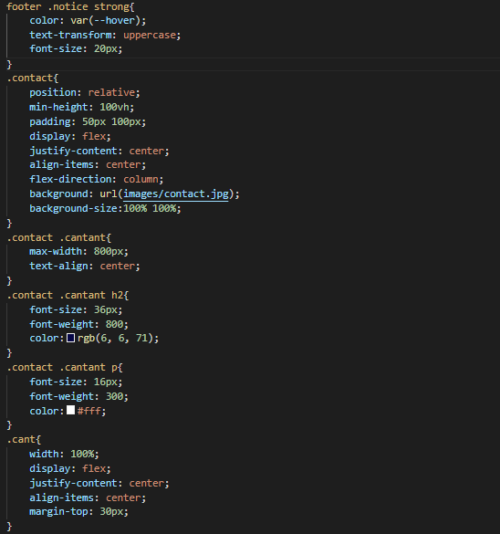

Figure: 44

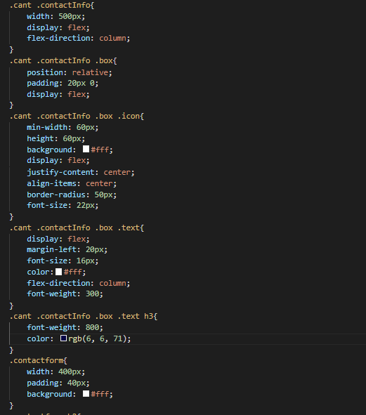

Figure: 45

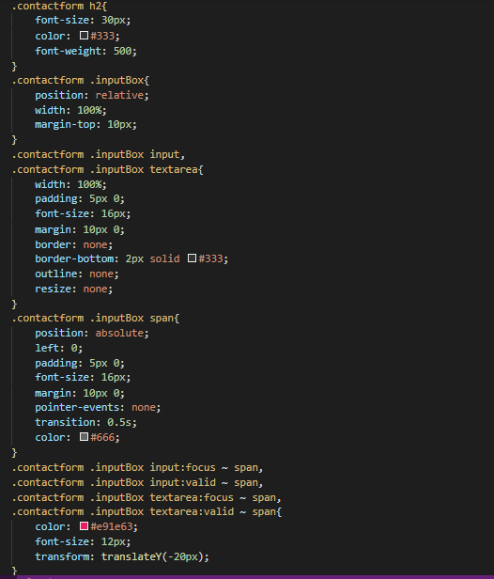

Figure: 46

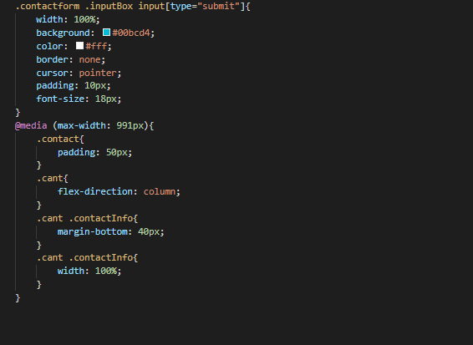

10.Javascript Page(Code View)

Figure: 47

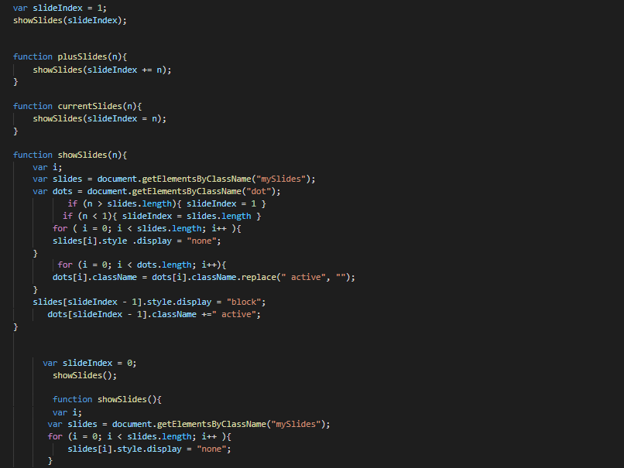

Figure: 48

